1.3 I can understand a range of tools and techniques and relate these to projects

I used numerous tools and techniques to help me create my website. The majority of my work was undertaken on my laptop which had all the applications I needed to create content and code as well as to store files. I have access to fast broadband which enabled me to quickly download and transfer files as well to carry out research for my content.

I used Visual Studio Code to create the code for my website. Visual Studio Code is a source code editor that allows me to create websites using HTML (hypertext mark-up language) and CSS (cascading style sheets). When reviewing updates to my website I opened my html file using Google Chrome which is a browser I am most familiar with and is a popular browser to use. An example of my work on Visual Studio Code is below;

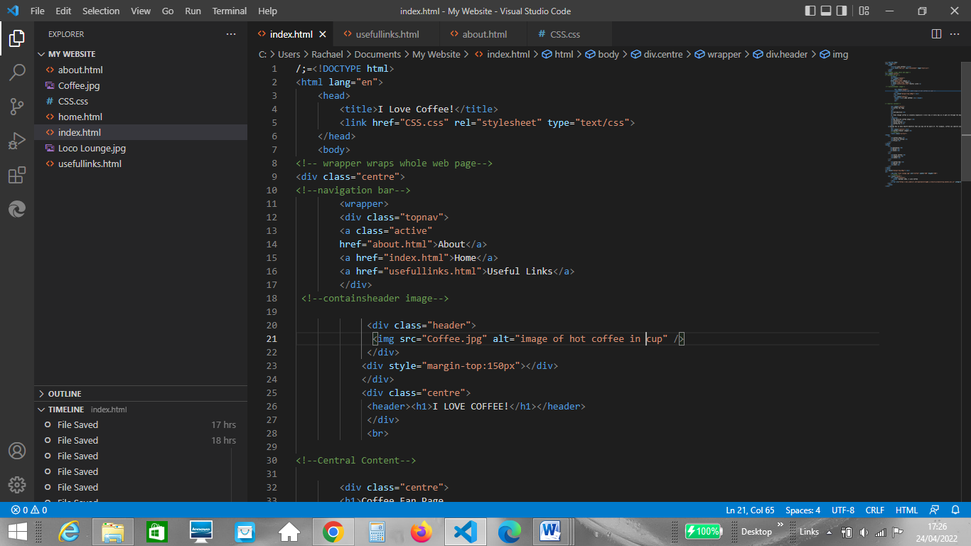

An example of my website opened in Google Chrome;

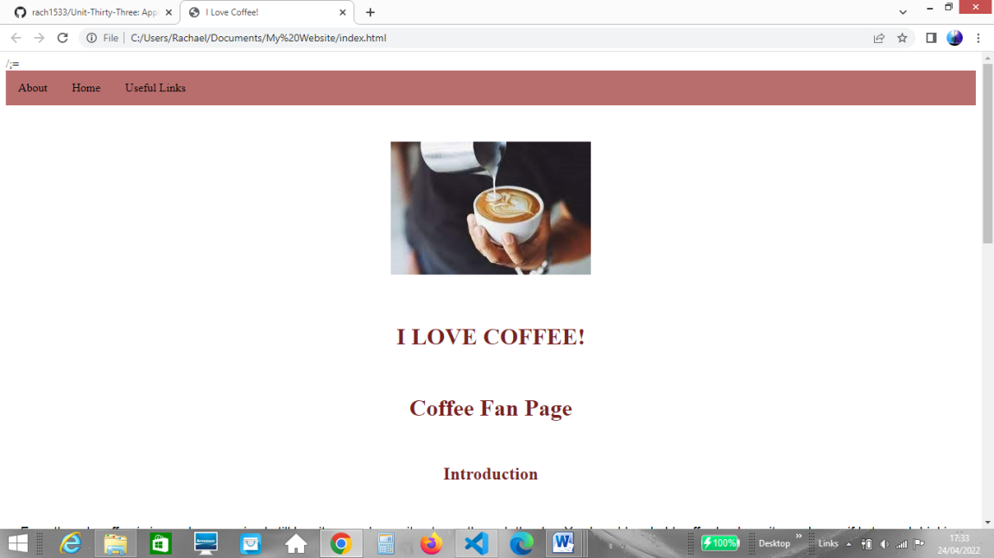  
We were given a task that required me to work collaboratively as a group to create a multipage website, with each of us contributing to the task. A SCRUM meeting was held and a SCRUM Master was appointed who we sent our work to. A screenshot of the website I created to complete the product backlog;

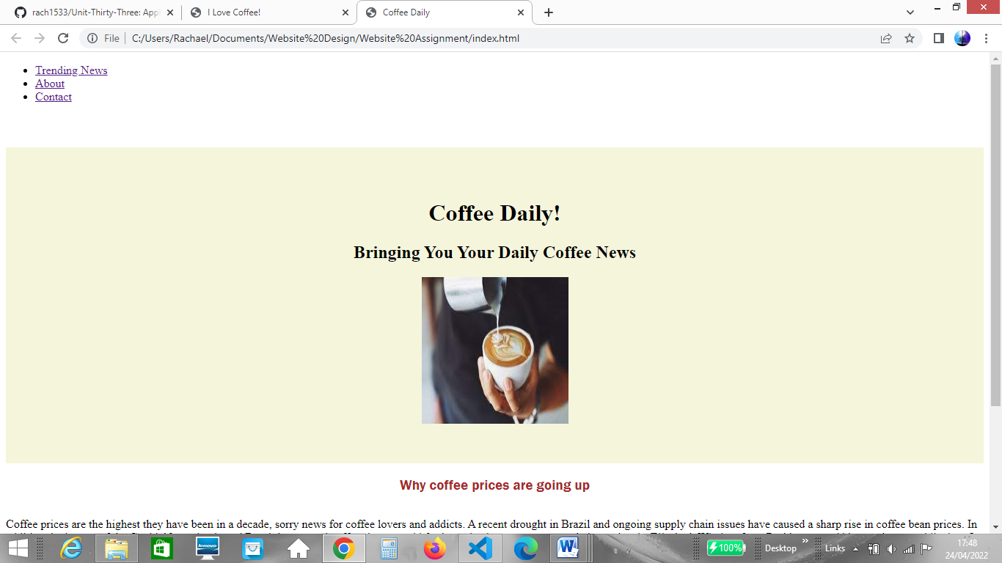

When completing my work I used a KANBAN board to visualise the status of each task. I created a board online using Trello;

